Richard Schall

CS-499-T4206: Computer Science Capstone

Southern New Hampshire University

March 22, 2021

**3-2 Milestone Two: Enhancement One: Software Design and Engineering**

1. **Artifact Description**

The artifact chosen for all the enhancements and my ePortfolio is the Weather Station application. This application was developed in CS 350 – Emerging Systems and Architecture. This application was developed January through the end of February 2021.

The application has two parts there is the backend software written in Python that is ran on a Raspberry Pi 3 unit. The raspberry Pi is an embedded Linux device running the Raspbian distribution of Linux. The second part is a dashboard application that runs on the web browser of a client PC. The dashboard uses JavaScript and graphs provided by CanvasJS.

1. **Artifact Justification**

I chose the Weather Station application because it encompasses almost all aspects of the aspects of my education at SNHU. Through enhancements, I can thoroughly demonstrate all the skills I have acquired. Specifically, the demonstration of Software Design/Engineering the Weather Station Python code through enhancements shows my ability to follow coding standards, documentation of code through appropriate code comments, and structure using functions and a configuration data file to stores the parameters of the application.

The enhancements made to the Weather Station include improved variable naming, editing of code comment, breaking out of functionality into separate methods, and the inclusion of a JSON configuration file to hold the application settings. The configuration file makes the application configurable without having to modify source code.

**Improved Variable Naming and Comments:**

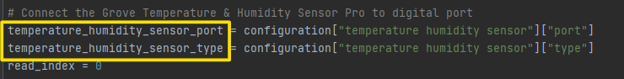

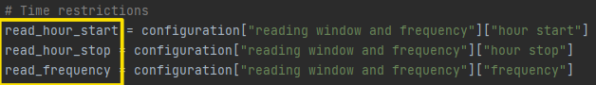

**Methods added to Break Out Functionality:**

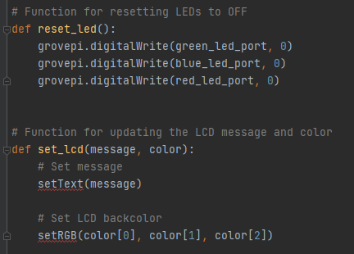

**Creation of JSON Configuration File:**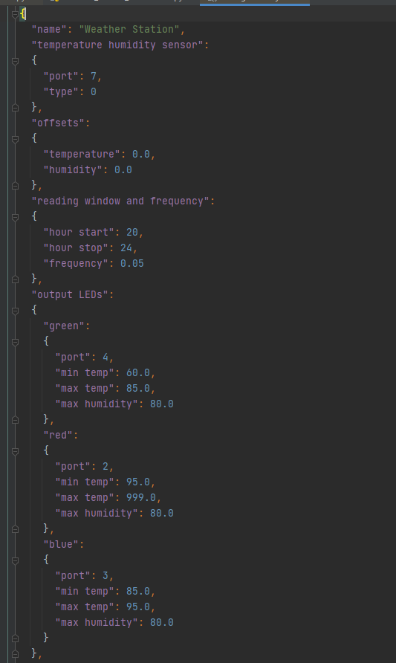

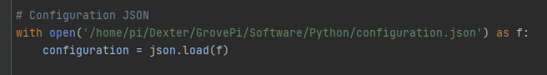

1. **Objectives**

I believe I have met course objectives with this enhancement. I may need to alter my outcome-coverage plan, I originally included improving performance by rewriting the application in C++ or by using Cython to facilitate the use of C++ components in the main Python application. This enhancement may be too ambitious for the timeline given. Major enhancements have been made so far, I feel like this project with the current enhancements demonstrates my knowledge of Software Engineering and Design.

**Reflection**

The process of doing the code review in Module Two was detrimental in helping me identify the enhancements that need to be made to the Weather Station application to demonstrate my knowledge of Software Engineering and Design and to have a solid artifact that can be a part of my ePortfolio.

The development of the enhancements themselves went rather smoothly. Performing and actual code review through a recording narrated by me was a little tough. I had trouble organizing my thoughts and overcoming the nervousness creating a presentation that shows my knowledge of the code I created that will be reviewed by someone with greater knowledge than myself. After having completed the review, I see the value in it completely. I look forward to improving my skill as a code reviewer.